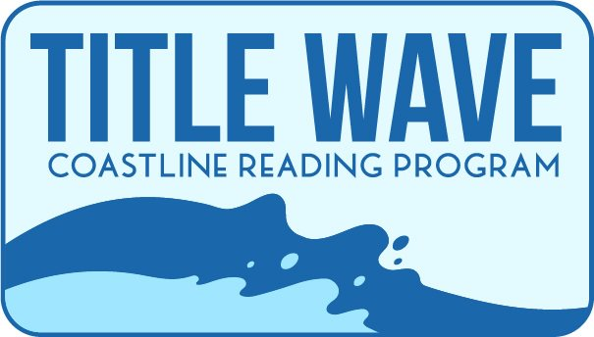

Mysterious Coastline Scavenger Hunt

Celebrate Title Wave by participating in the cozy mystery scavenger hunt. Complete 15 of the tasks and be entered to win one of the bakers’ dozen prize baskets. Complete all 20 and you will be entered to win a basket plus have major bragging rights. Before you start, obtain a Title Wave sticker from your local Coos or Curry County Library. Not every clue requires a picture, but if it does the sticker must be present.

- Take a selfie with a cat or dog.
- Take a picture of a local bakery or of your homemade baked goods.
- Take a picture of yourself with a local police officer, police car, or K-9 Officer (or have them hold the sticker for you and take a picture).
- Take a picture of a local brewery, bottle of Oregon beer, or bottle of Oregon wine.
- Take a picture of a local coffee shop or of you drinking coffee/tea.
- Take a picture of a local bookstore.
- Take a picture of a yarn/quilt/craft store or of your latest yarn/quilt/craft project.
- Take a picture of yourself in a local park.
- Take a picture of yourself at your local library.
- Take a picture of one of your recent check outs from the library.
- Take a picture of your garden, a friend’s garden, or a public garden.
- Name the last library program you attended.
- Name your favorite mystery book.
- Name the closest cemetery to where you live.
- Take a picture of yourself at the local town “monument”. You will need to call your local library to learn what that monument is.
- Submit your favorite recipe.
- Name your favorite detective from a book, TV show, or movie.
- Take a picture of your favorite reading spot.
- Take selfie in front of a local Bed & Breakfast.
- Take a picture of your bookshelf.
- Bonus Clue – will be given out on May 6th during Getting to Know Author Ellie Alexander program

MAKE SURE YOUR TITLE WAVE STICKER IS IN EACH PHOTO YOU TAKE

Once you have completed your entries, please email them to: TItleWave2021@coastlinelibrarynetwork.org with Scavenger Hunt - (your last name) in the subject line. If you have lots of photos, feel free to send multiple emails. Please include your name and a phone number in the email for contact purposes. Submitted pictures may be used for library promotions. If you do not want your photos used, please state that you Opt-Out of the photo use in the email.

*All references to local mean Coos or Curry County.

