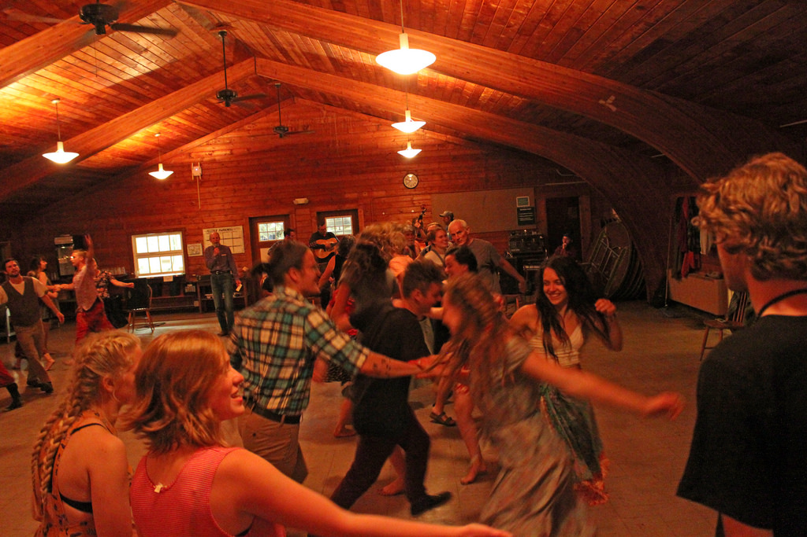



To learn more about the South Coast Folk Society, you can email

Southcoastfolksociety@gmail.com

or call 541-404-8267

525 Anderson Avenue

541-269-1101

https://www.coosbaylibrary.org

Folk Dancing

Who: Ages 8+

What: Beginner’s dancing for Circle, Line, Square, and Contra dancing styles.

When: May 21st, Tuesday, from 6:00-7:30pm

Where: Coos Bay Public

Library Myrtlewood Room

Coos Bay Public Library will be working with the South Coast Folk Society to host a free lesson on Folk Dancing with live music!

No previous experience or partner are required; participants are advised to wear casual clothing.

Spots are limited, so those who are interested are advised to register by either calling the library, or by registering on the library events calendar online.